1. Deploy the custom image with any application installed.

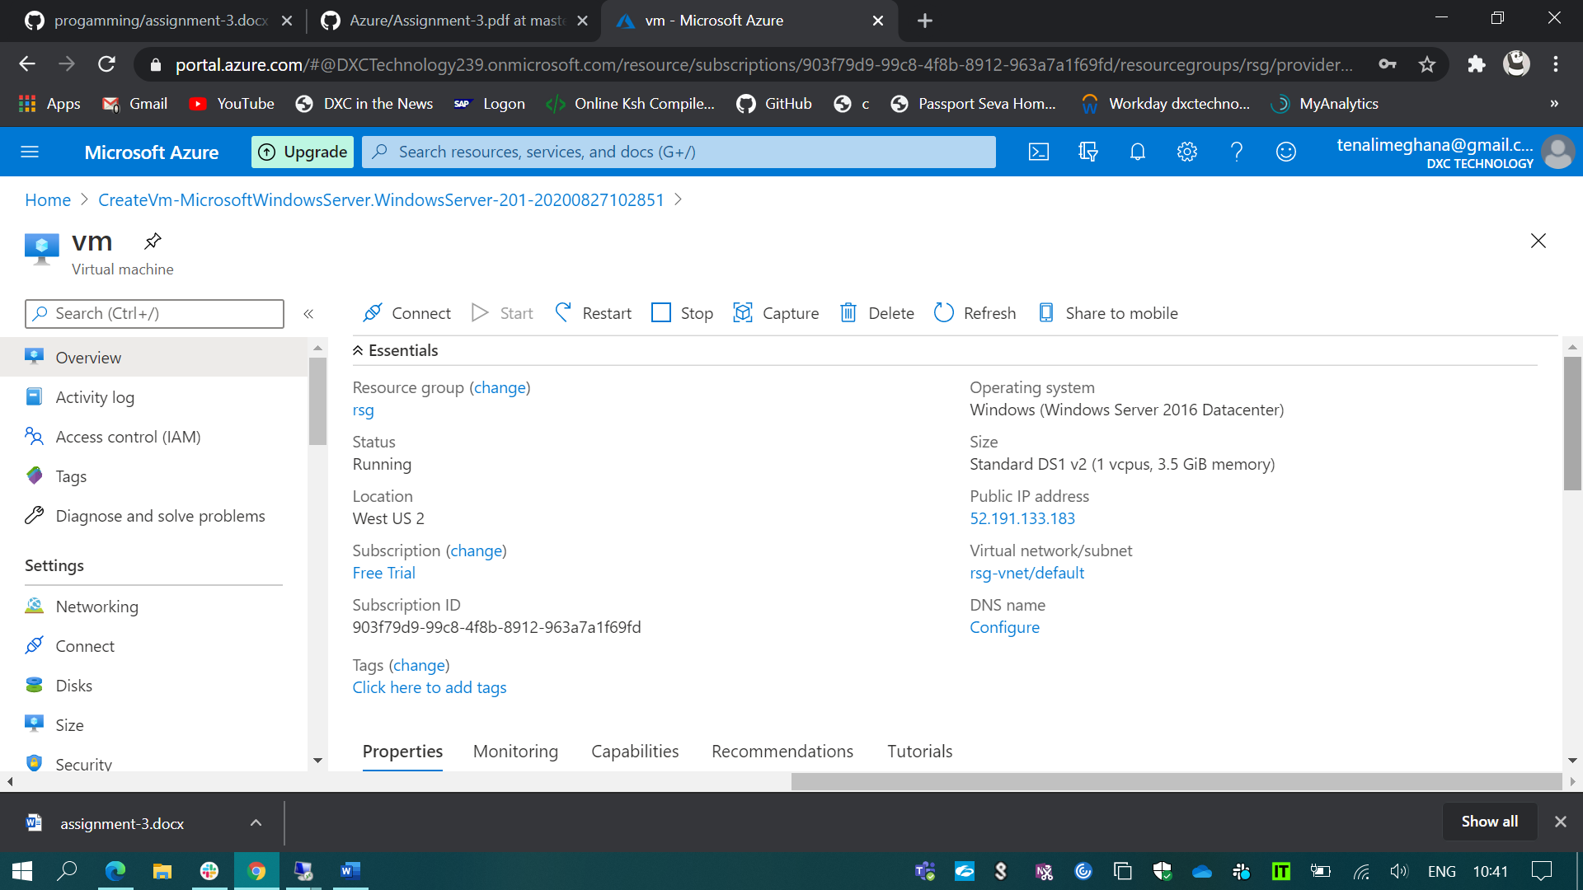

I’ve created a VM & installed the notepad++ in that as shown in the below snip.

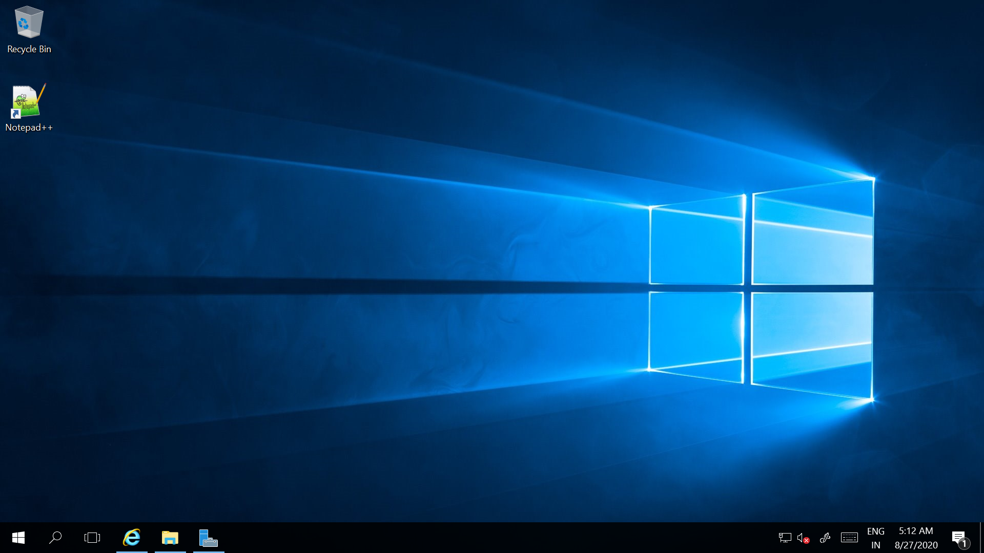

And I’ve created the custom image of VM-1. Using that custom image I’ve created the another VM.

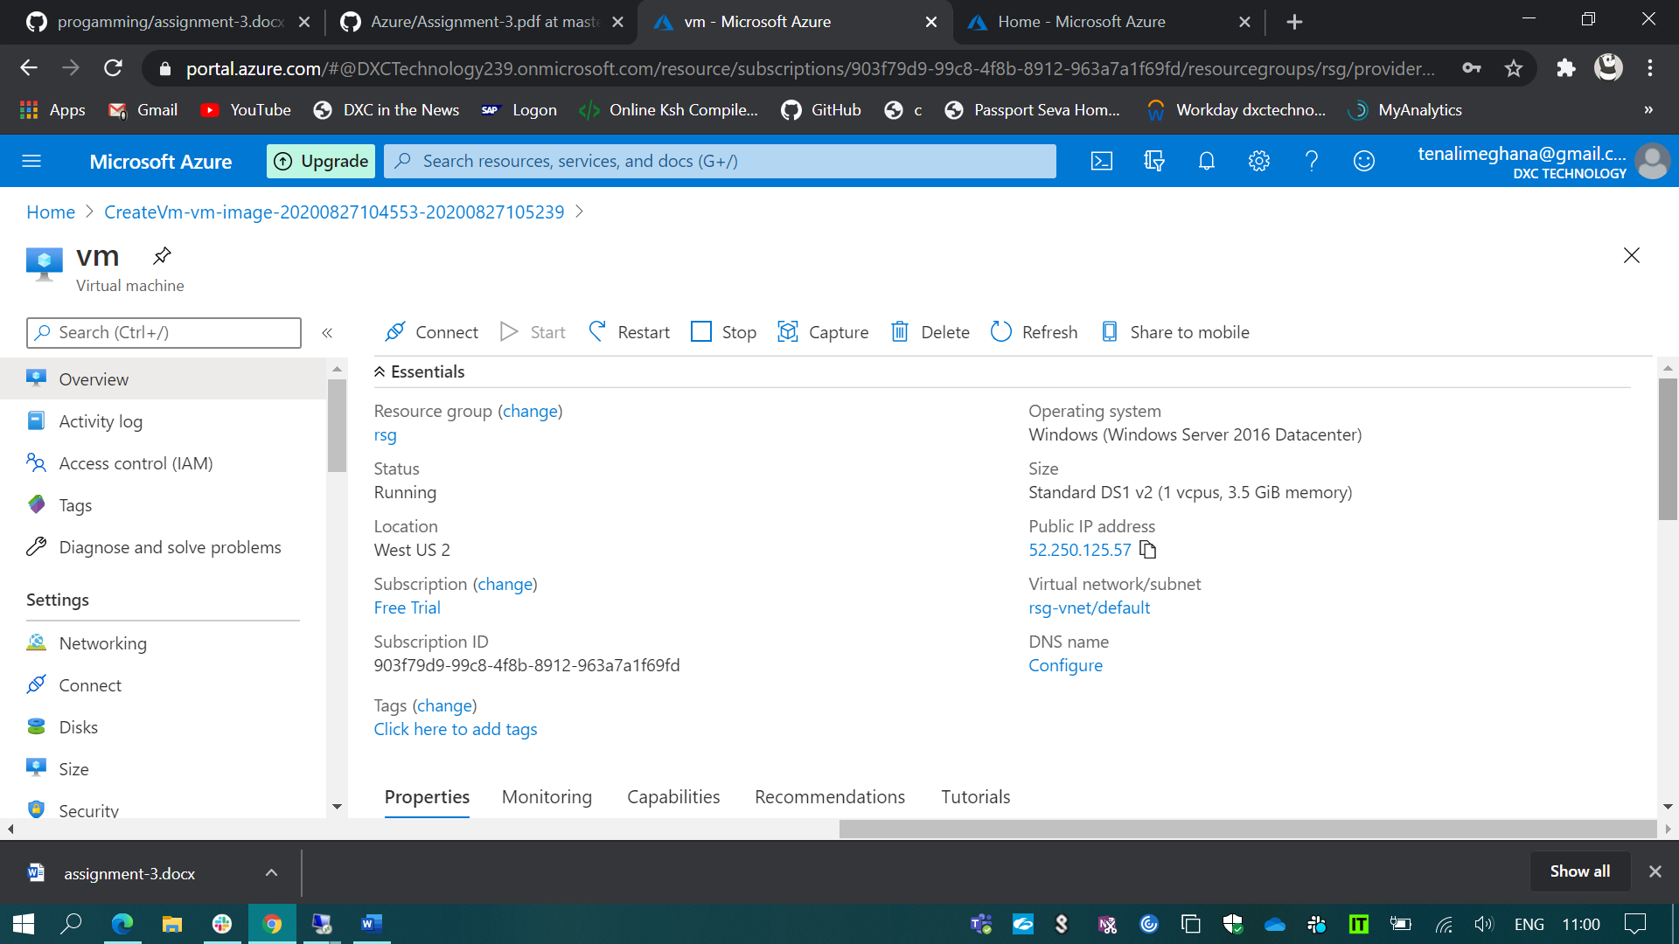

As shown in the below snip the notepad++ is pre-installed in my VM-2.

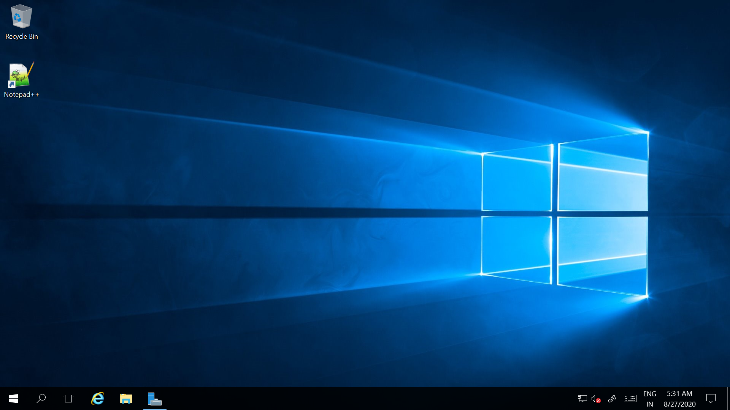

1. Created a virtual network in EAST ASIA location.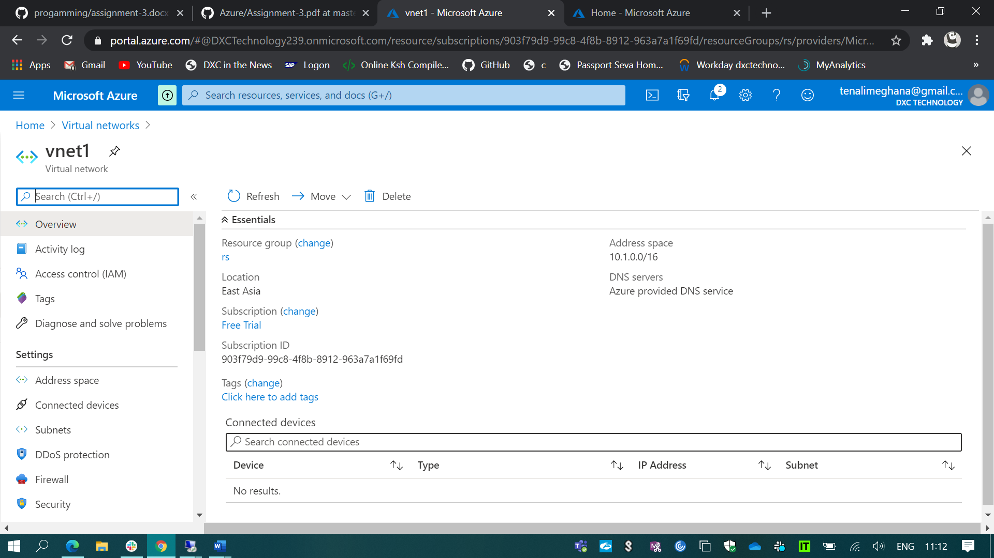

And Created another virtual network in west US location.

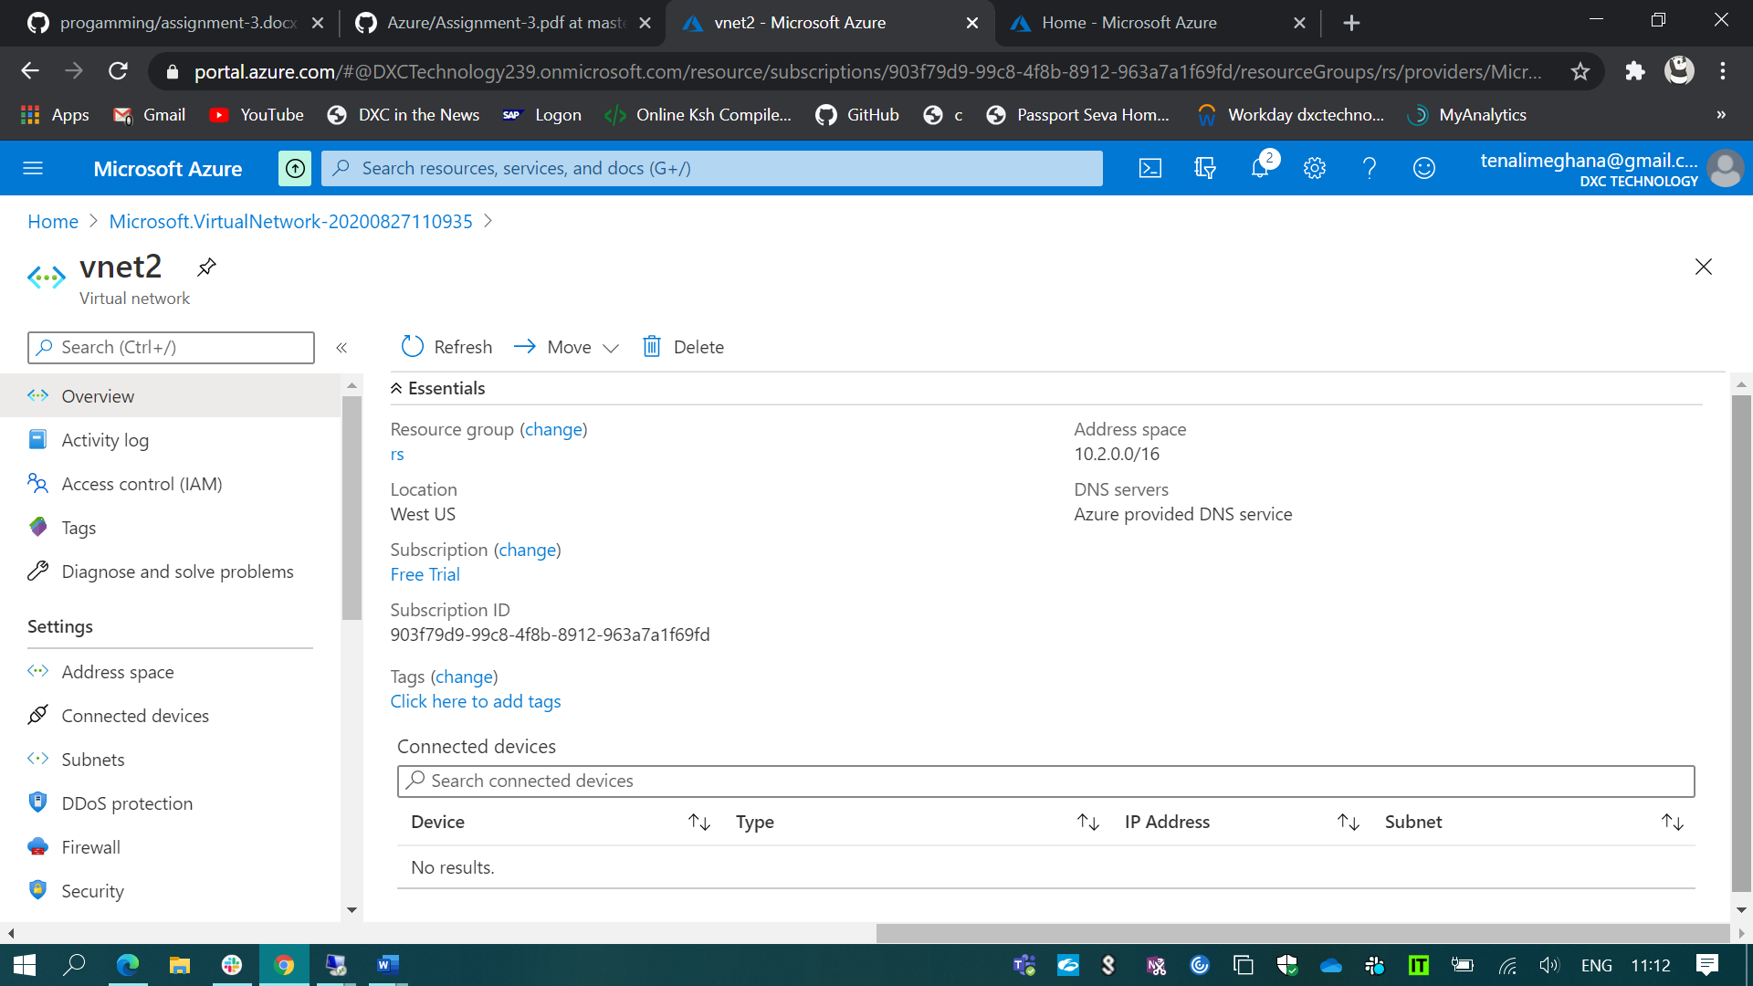

And also created the two virtual machines in the same locations which I’ve used for the creation of virtual networks. 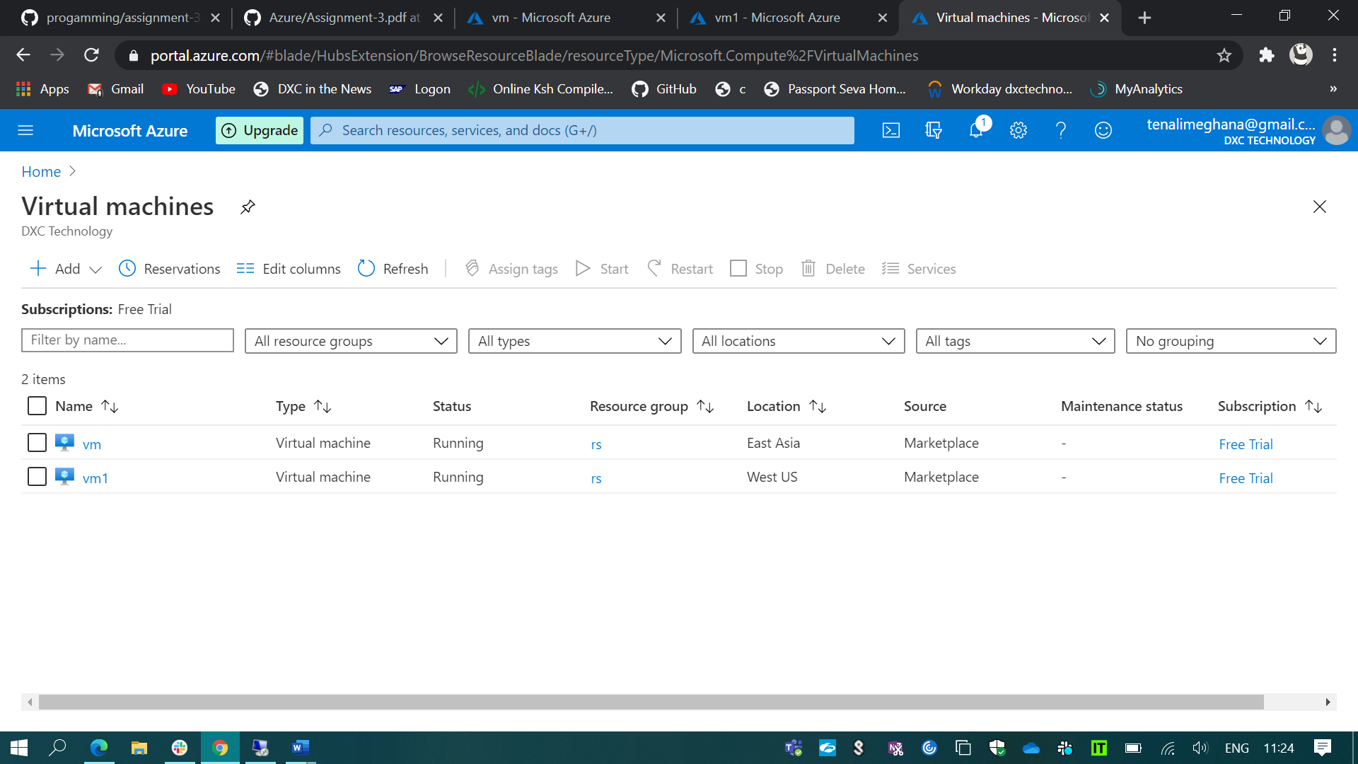

I’ve peered the vnet1 to vnet2 using network peering.

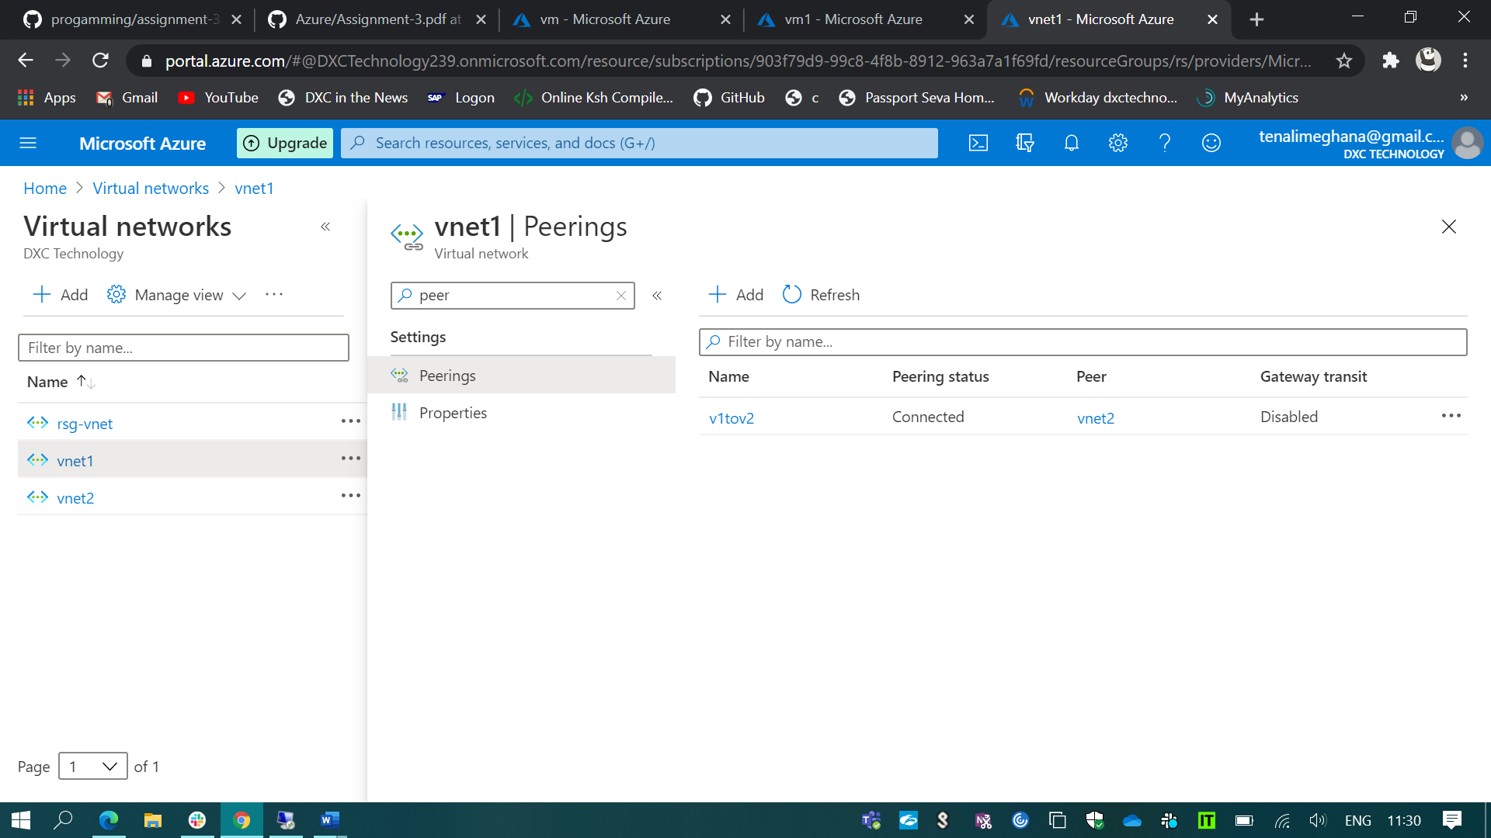

And I’ve also peered the vnet2 to vnet1 using network peering.

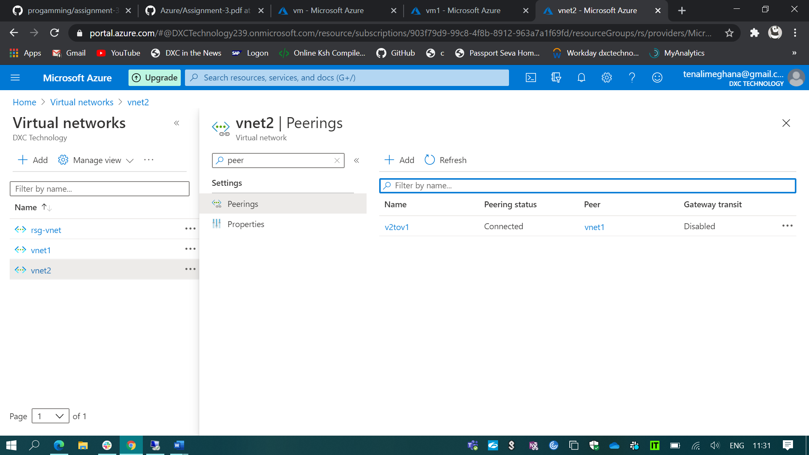

And I’ve opened my VM which is connected to my vnet1 network.

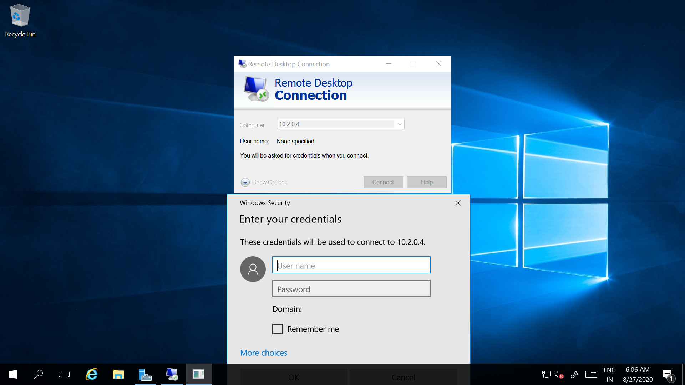

And from that VM-1 I’ve opened the VM-2 which is connected to vnet2 by using the private IP of VM-2. 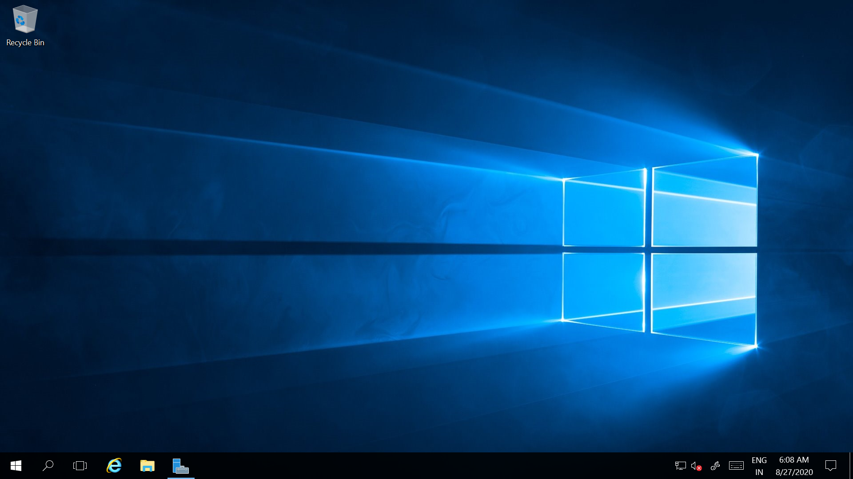

1. To create a point to site VPN for my virtual network which is located in west US

(i). First, I’ve created a gateway subnet.

(ii). And I’ve created the VPN in the same virtual network.

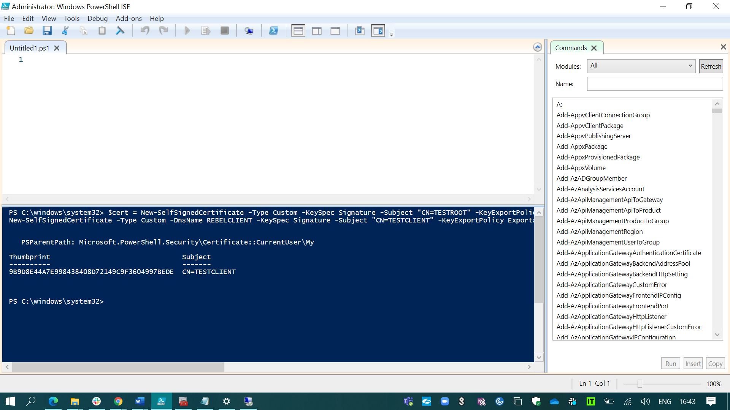

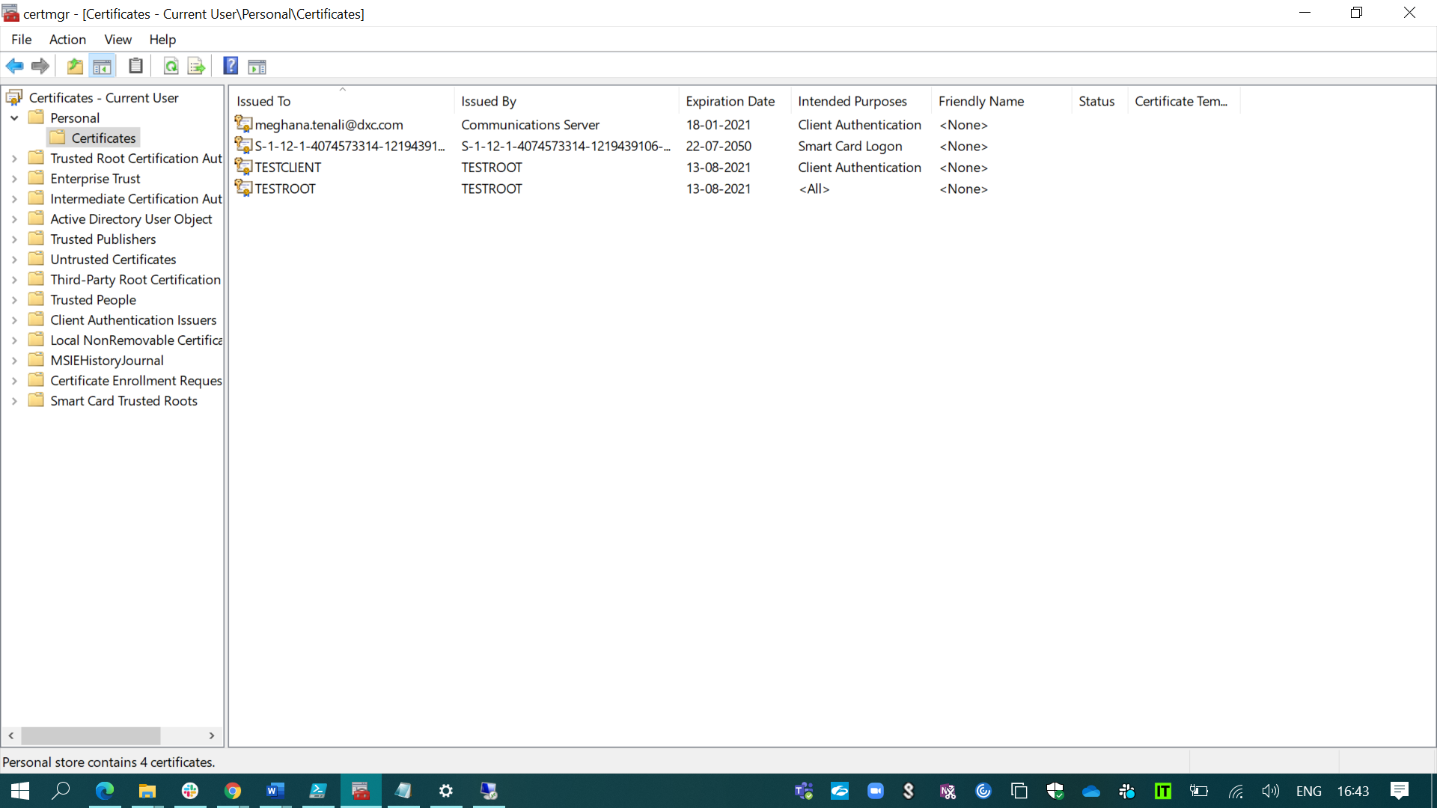

By using the Windows PowerShell ISE I’ve generated the client & root certificates for the User VPN configuration.

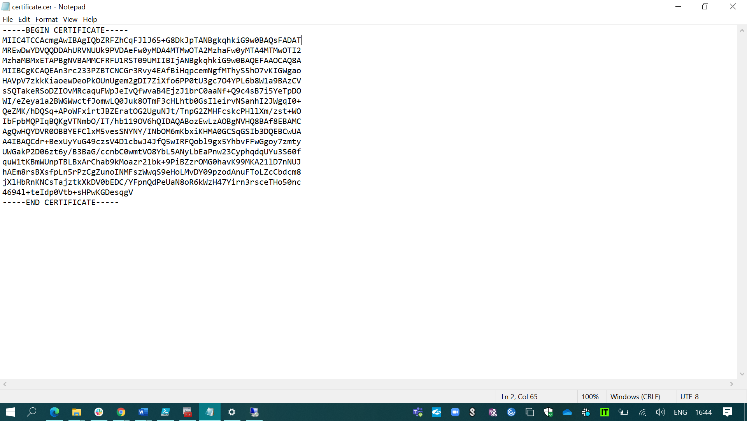

And I’ve exported the root certificate into the azure portal by copying the key. 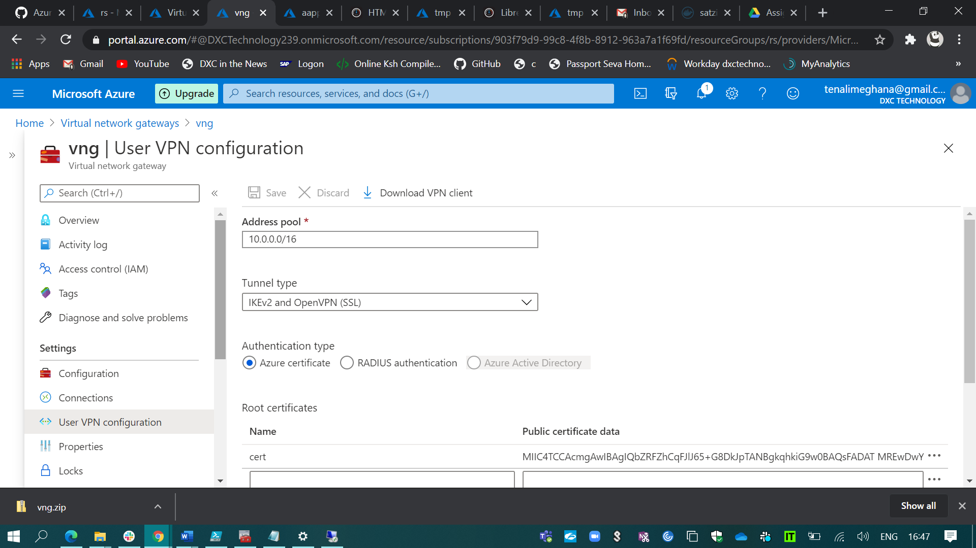

And user VPN has been created and before connecting to the VPN we have to download the VPN client in our PC.

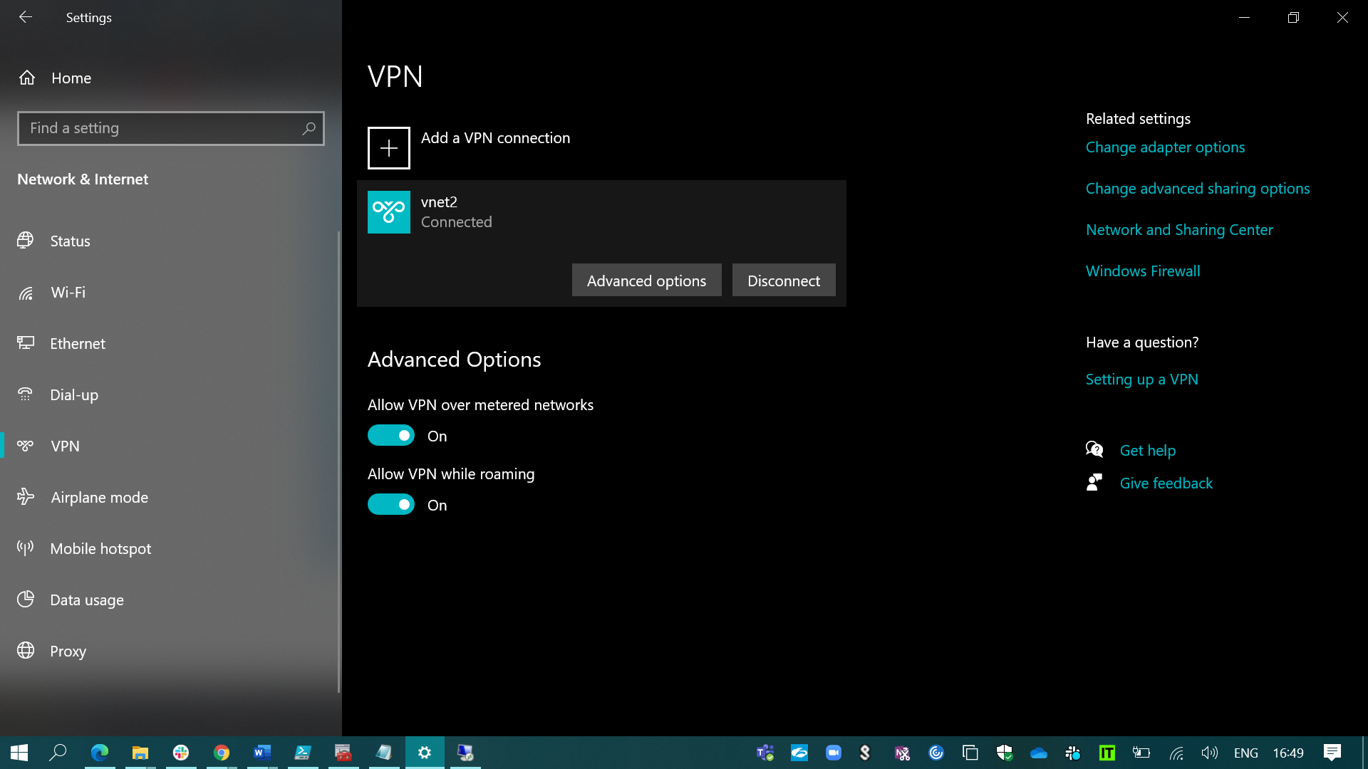

And then connect to the VPN & opened the VM with the help of it’s private IP which is connected to my virtual network vnet2 without any blockers.

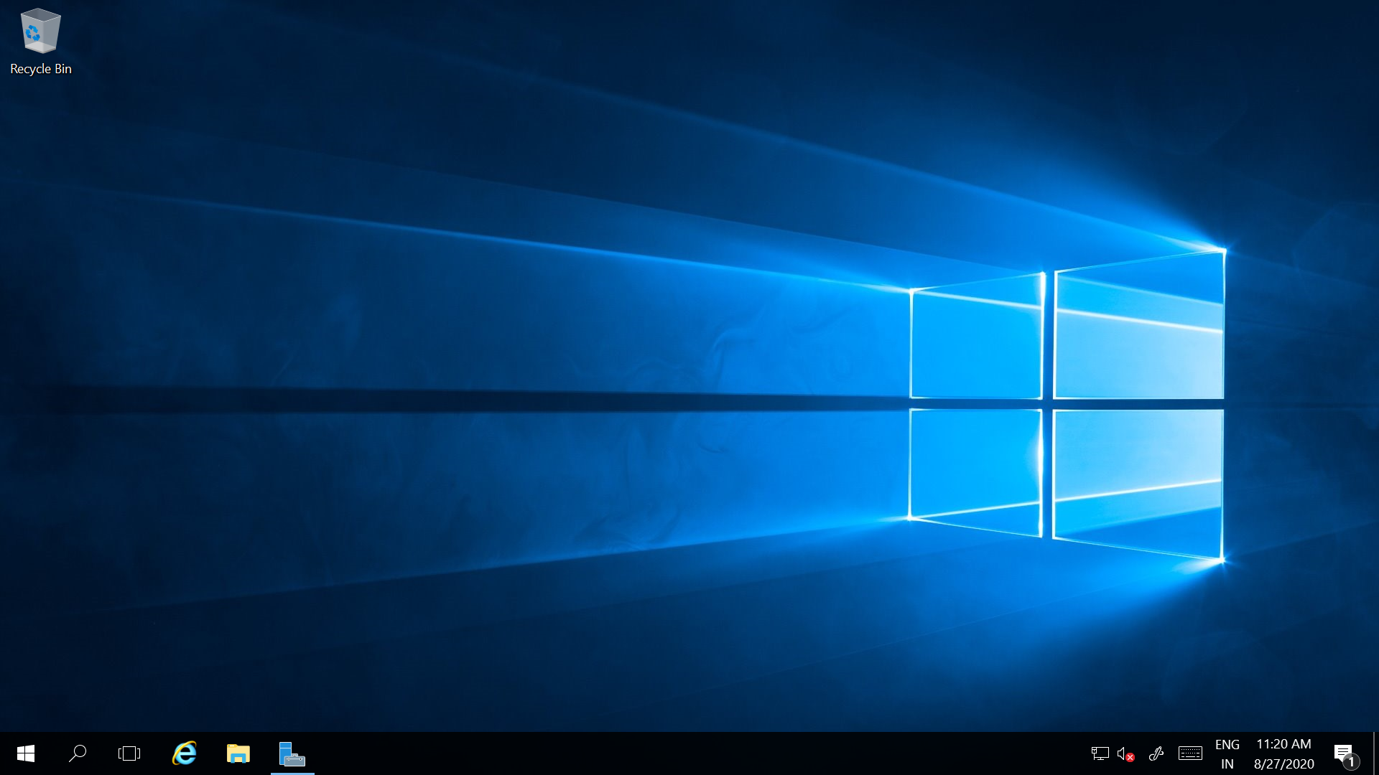

1. Created two web applications.

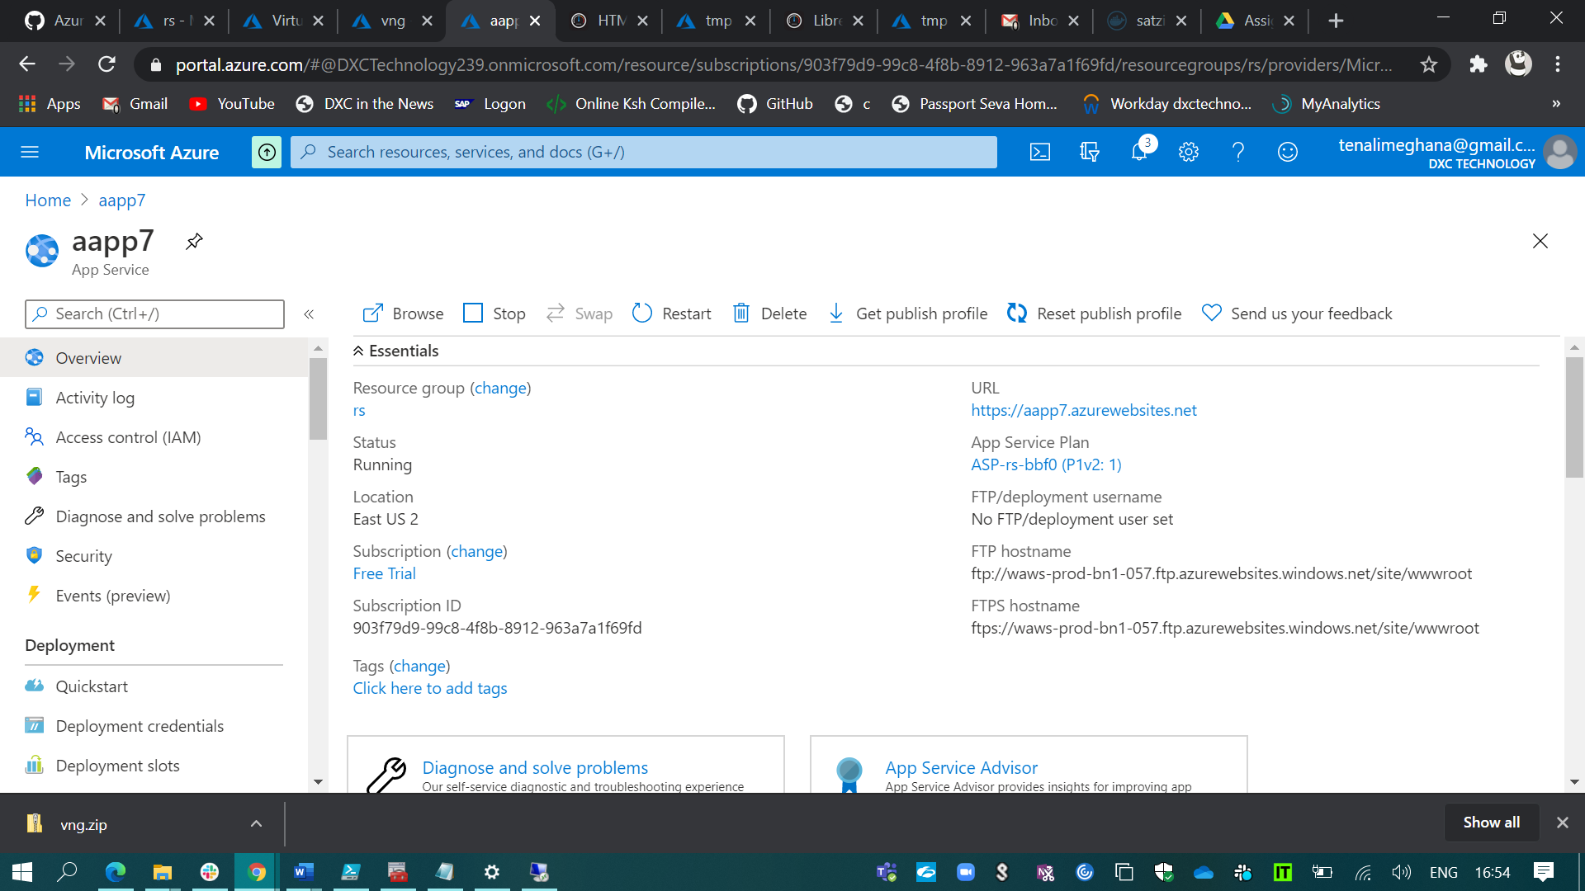

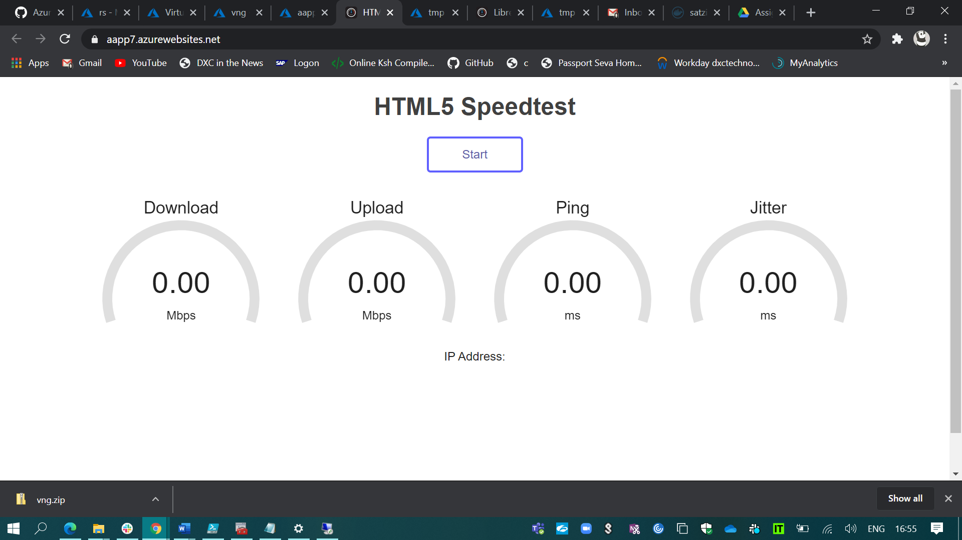

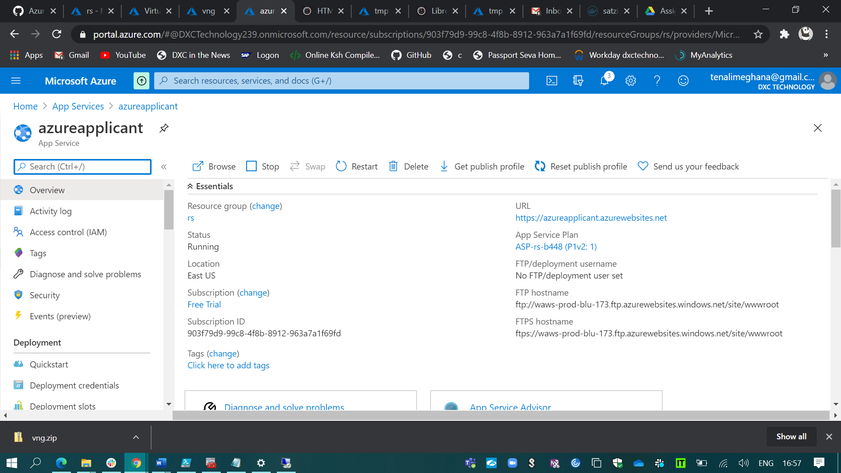

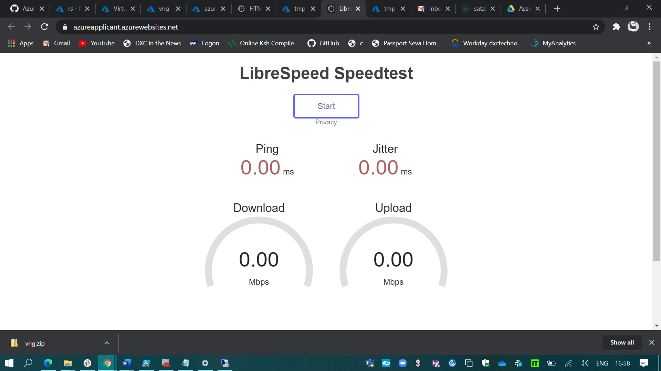

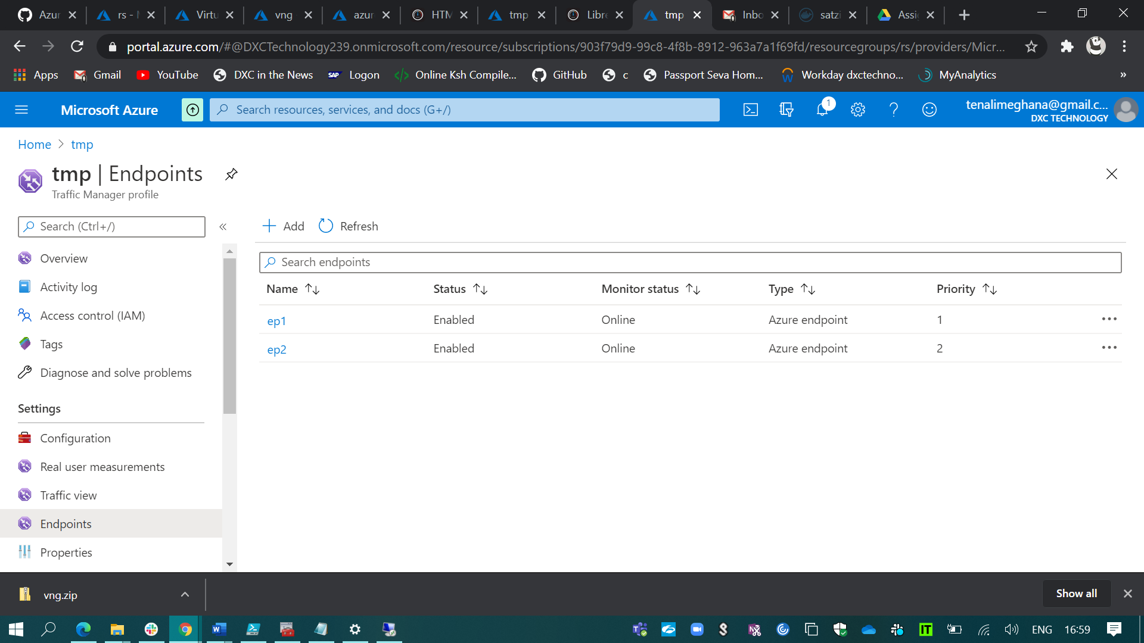

And kept those two web applications in the traffic manager profile which has been created using priority routing method.

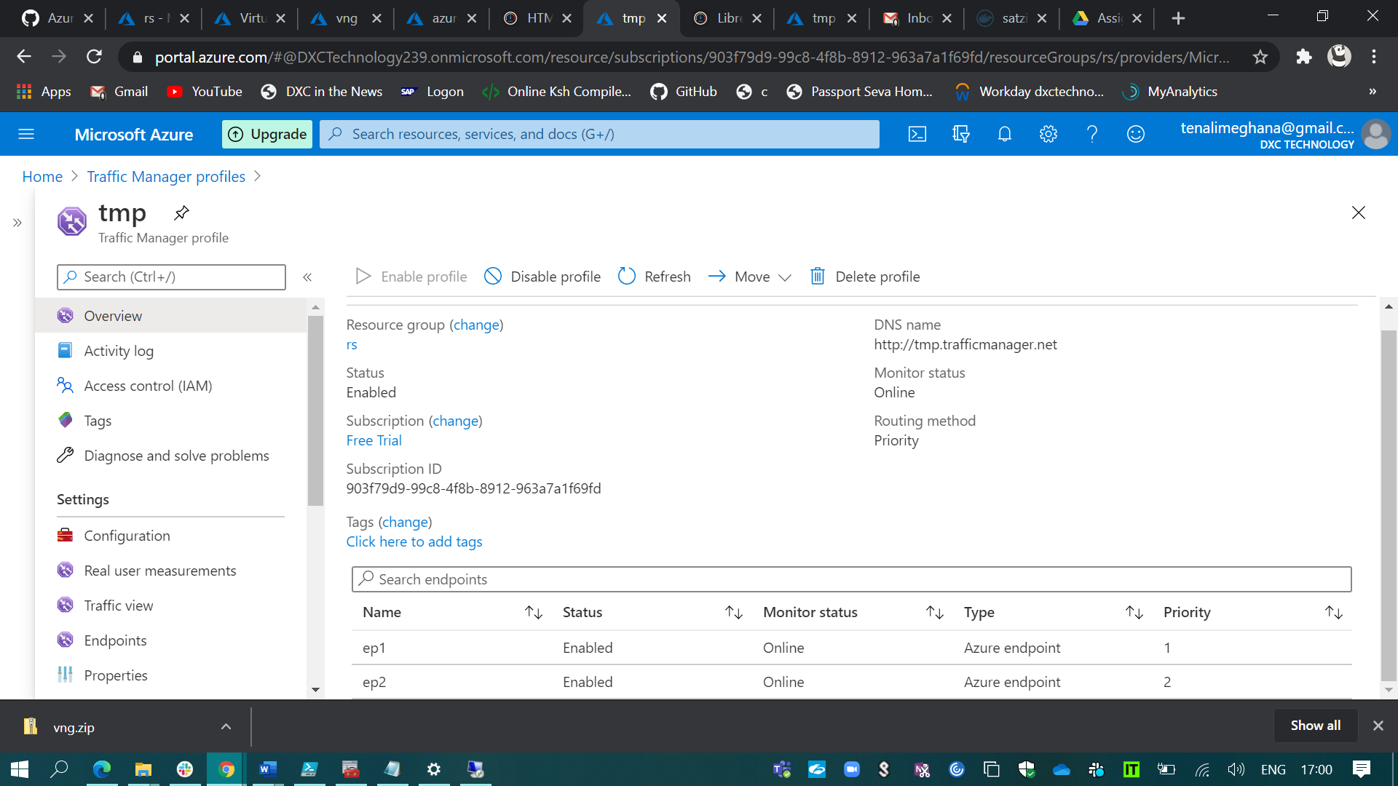

1. The below snip defines the backup solution of a VM using the new backup policy with 10 days retention period.

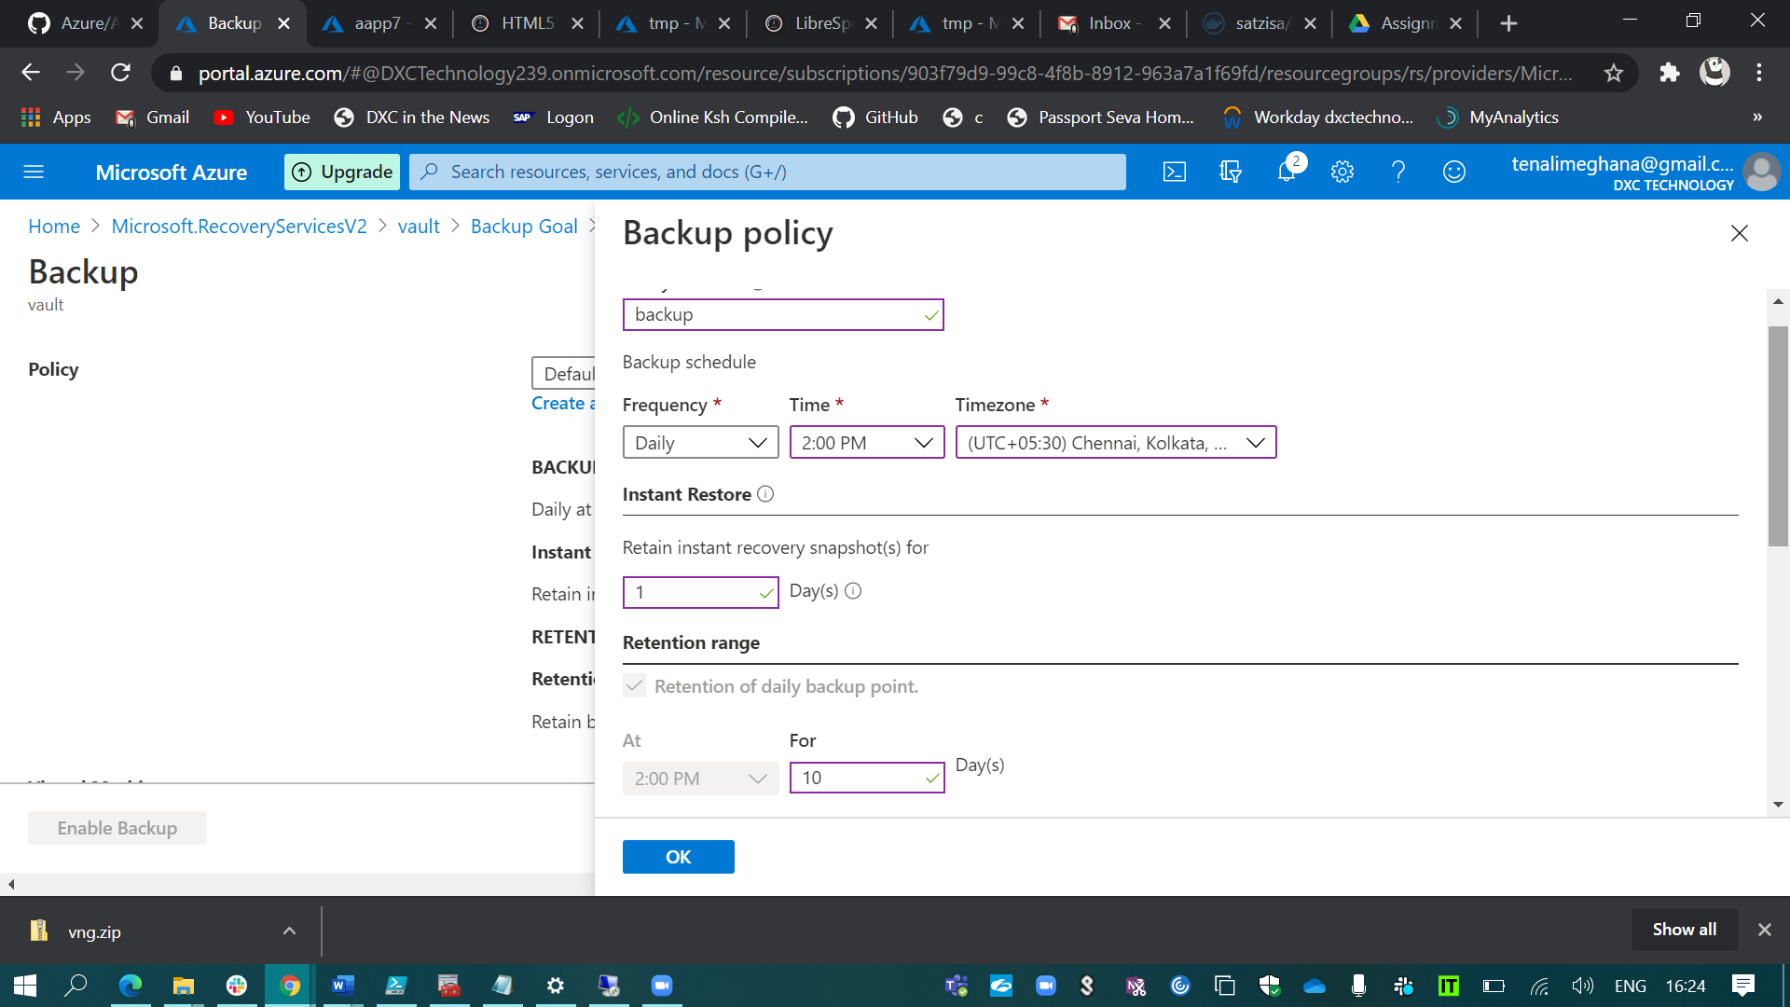

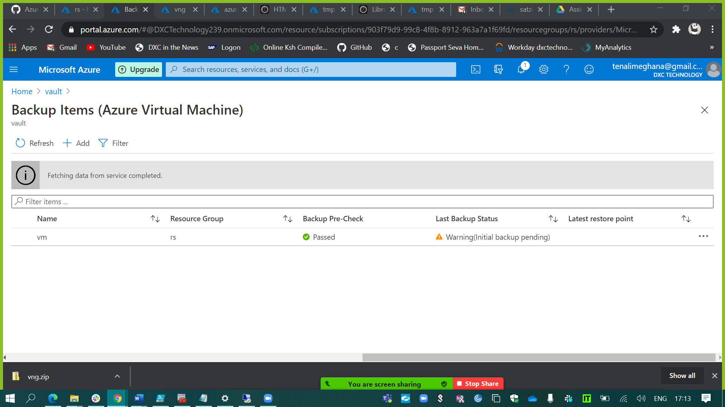

1. The below snips define the on premises backup.

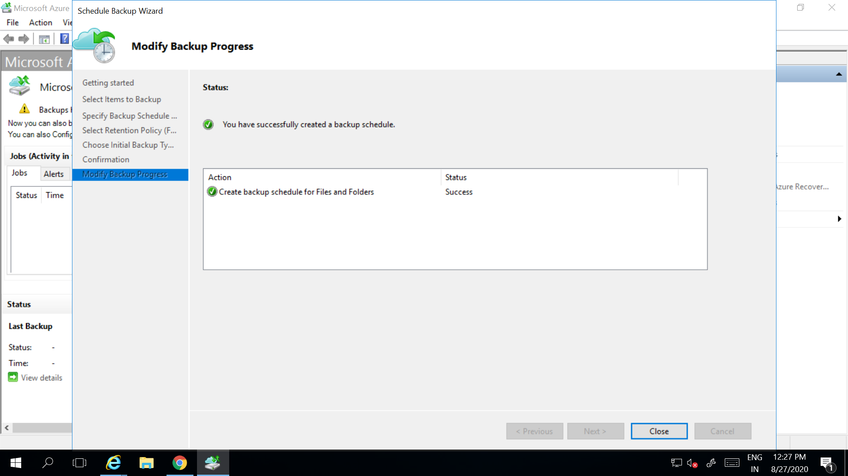

I’ve done the backup of Volume D and excluded some files from the backup.

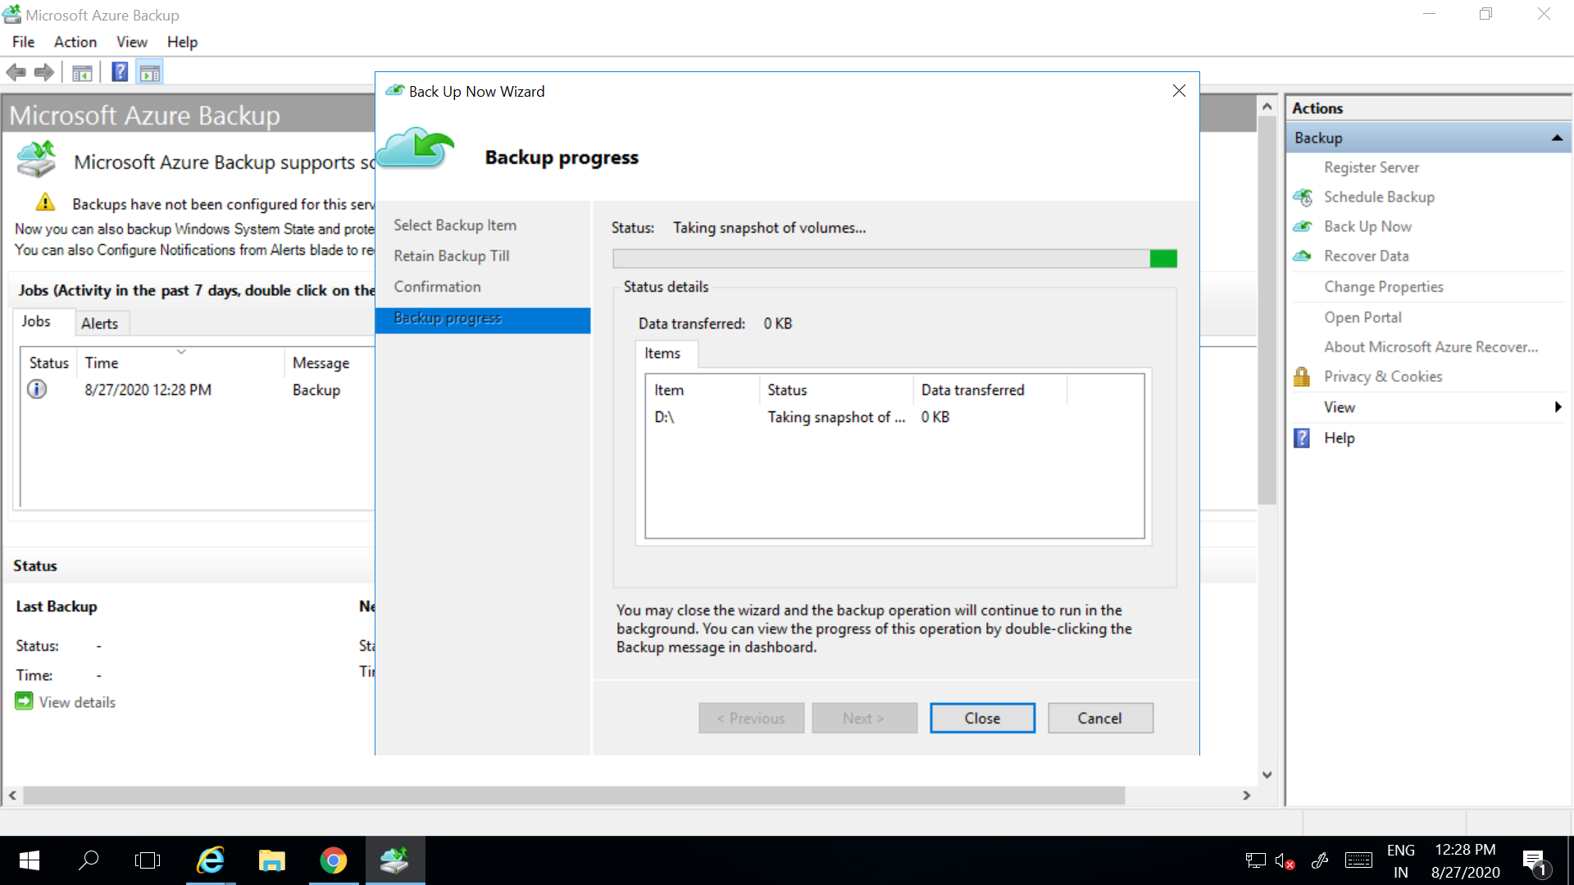

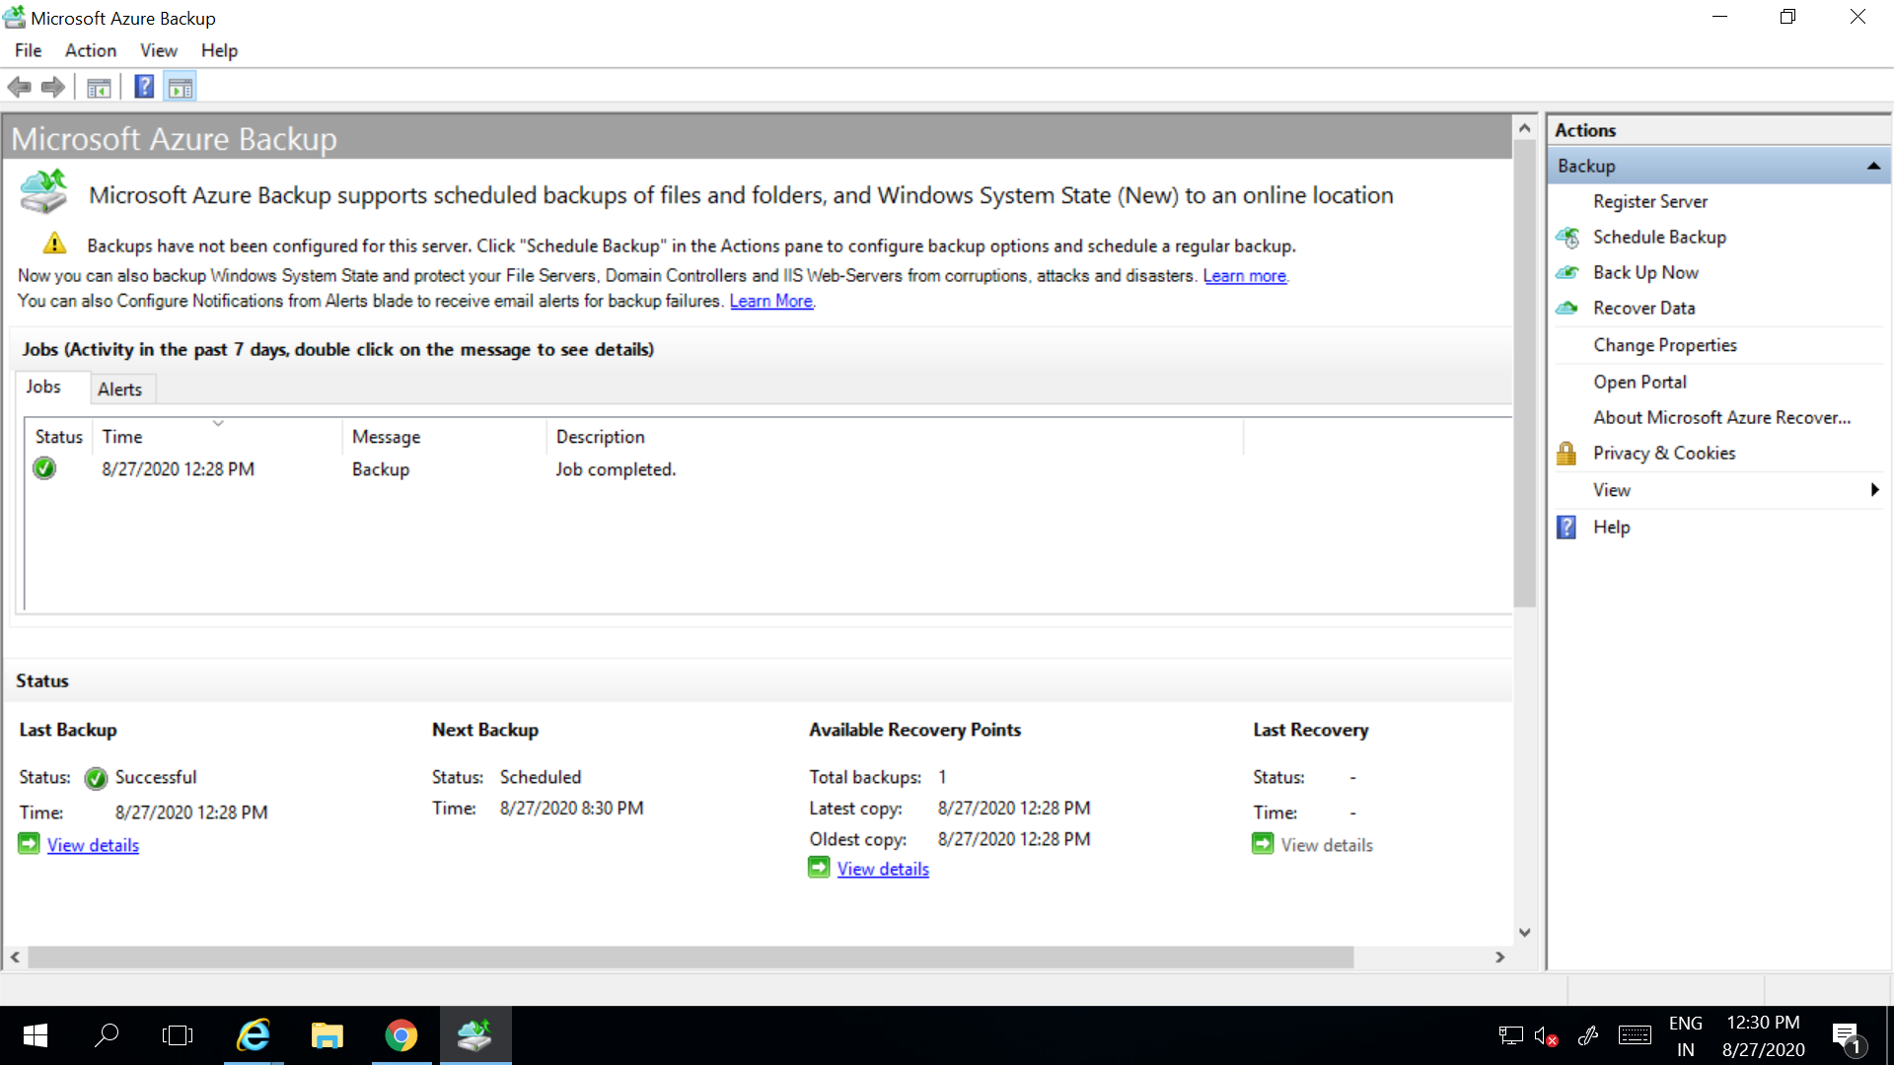

1. First, we need to create the azure recovery service vault and then replicate the VM from East US 2 location to West US.

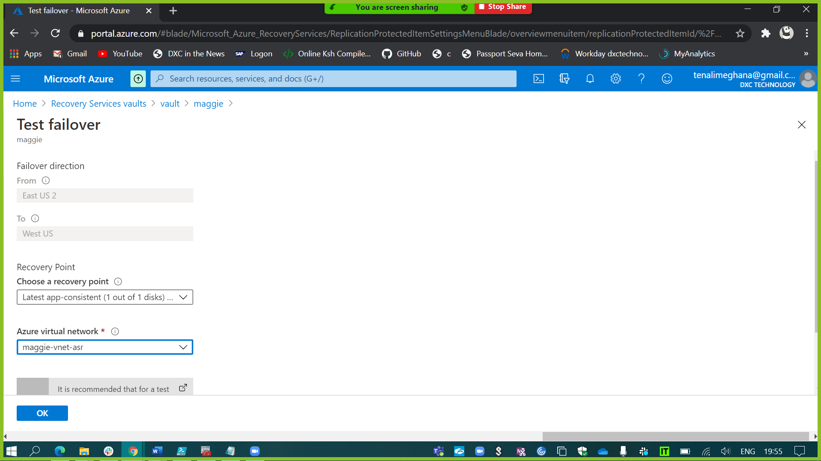

And after the completion of replication & synchronization, run the test failover & clean it up. 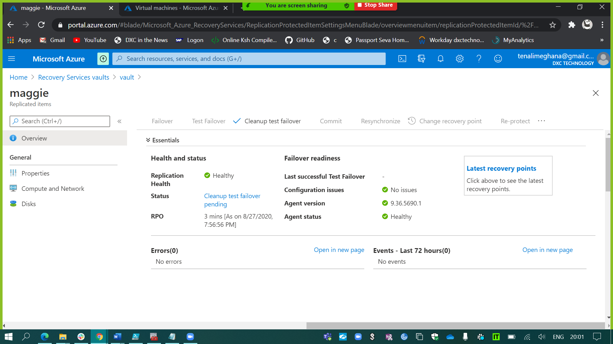

After the test failover I’ve created a failover of my virtual machine which has been created in West US location.

